**Differential expression analysis of microarray data of the house mouse (*Mus musculus*)**

**Results**

The values of the first and second principal component (PC1 and PC2) were compared to each other in the scatterplot (figure 1). For the wild type (blue dots), we detected values which were spread out for both components. In contrast, the values for the knockout type (red dots) were all clustered for the first component but not for the second.

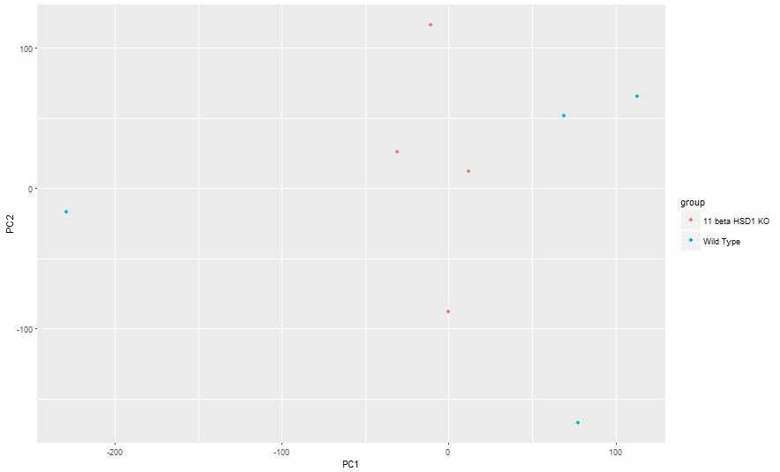

Figure 1: Comparison of PC1 against PC2 in wild type and knockout groups of house mice (*Mus musculus*) (11 beta HSD1 KO)

In order to verify that the knockout worked, we plotted the expression levels of the responsible gene for both groups. As shown in figure 2, the expression level for this gene in the knockout group was remarkably lower than in the wild type group, which implied that the knockout worked. All values were situated above 600 for the wild type, whereas the knockout group generated a gene expression close to zero.

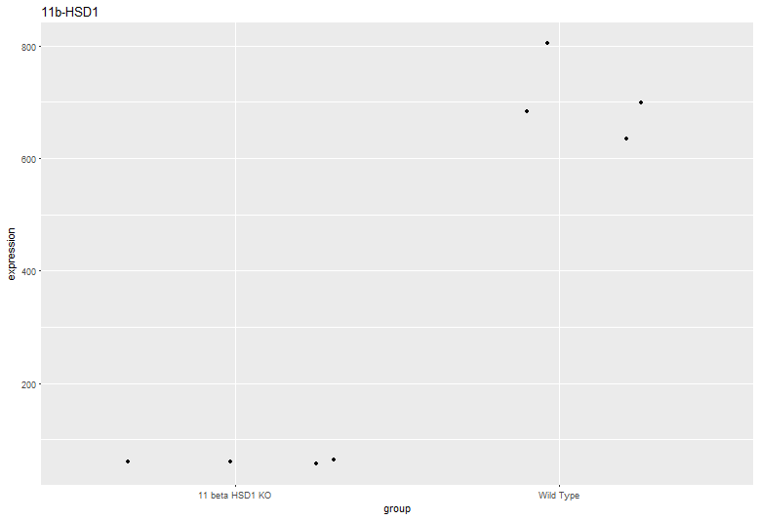

Figure 2: Expression levels of the gene 11b-HSD1 in the knockout group (11 beta HSD1 KO) and in the wild type

After comparing the expression levels of every gene, we detected significant differences between the expression level of the wild type and the knockout group. As shown in figure 3, the expression level of the wild type differed significantly (10% FDR- level) from the expression level of the knockout group in 23 genes.

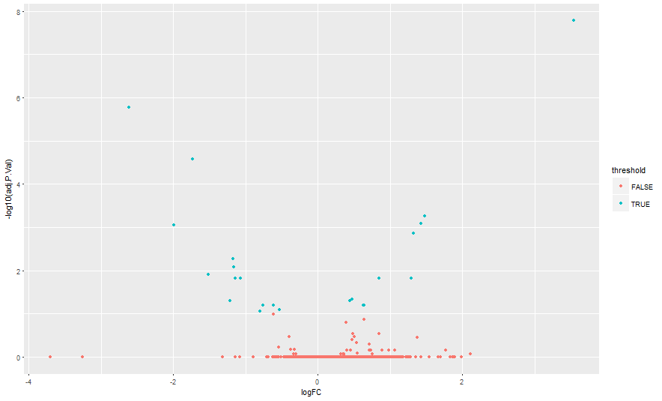

Figure 3: Comparison of gene expression rate between wild type and knockout groups (11 beta HSD1 KO); red dots indicating nonsignificant differences; blue dots indicating significant differences; significant threshold was set at a 10% false discovery rate

**Discussion**

The aim of the present study was to investigate the effect of a knockout of the gene 11b-HSD1 in house mice (*Mus musculus*). This gene is involved in spatial memory impairment in older mice by means of decreasing the expression of specific neuronal transcription factors. Correspondingly, we hypothesised that the knockout group would show intact spatial memory given that knocking out 11b-HSD1 would increase the expression of the neuronal transcription factors that are responsible for an unimpaired memory function.

We compared gene expression levels in hippocampal tissue between a wild type population and a 11b-HSD1 knockout group of house mice. Firstly, a principal component analysis demonstrated higher proportion of variance in the wild type compared to the knockout group. Closely clustered values in the knockout group indicated very poor variation between these values in this population. We found 23 genes that exhibited significant differences in their expression level between the two groups of mice. Thirteen were significantly more expressed in the knockout group, whereas ten showed significantly less expression (table A1).

The findings of our study supported our hypothesis; genes that contribute to memory loss were downregulated, whereas the expression of neuronal transcription factors was upregulated (table A2).

In conclusion, mice did not develop spatial memory impairment when the corresponding gene was knocked out. Further investigations could identify if that phenomenon is transferable to humans.

**Appendix**

Table A1: Significantly upregulated and downregulated genes

|  |  |
| --- | --- |
| **Gene Name** | **Expression level** |
| phosphatidylserine decarboxylase, pseudogene 3(Pisd-ps3) | upregulated |
| phosphatidylserine decarboxylase, pseudogene 3(Pisd-ps3) | upregulated |
| suppressor of Ty 16(Supt16) | upregulated |
| phosphatidylserine decarboxylase, pseudogene 1(Pisd-ps1) | upregulated |
| phosphatidylserine decarboxylase, pseudogene 1(Pisd-ps1) | upregulated |
| dynein, axonemal, intermediate chain 2(Dnaic2) | downregulated |
| REST corepressor 3(Rcor3) | upregulated |
| RIKEN cDNA 4930453N24 gene(4930453N24Rik) | upregulated |
| hydroxysteroid 11-beta dehydrogenase 1(Hsd11b1) | downregulated |
| retinitis pigmentosa GTPase regulator interacting protein 1(Rpgrip1) | upregulated |
| EF-hand calcium binding domain 7(Efcab7) | downregulated |
| transmembrane protein 206(Tmem206) | upregulated |
| phosphatidylserine decarboxylase, pseudogene 3(Pisd-ps3) | upregulated |
| integrator complex subunit 7(Ints7) | downregulated |
| phosphatidylserine decarboxylase, pseudogene 3(Pisd-ps3) | upregulated |
| gamma-aminobutyric acid (GABA) A receptor, subunit alpha 2(Gabra2) | downregulated |
| gamma-aminobutyric acid (GABA) A receptor, subunit alpha 2(Gabra2) | downregulated |
| phosphatidylserine decarboxylase, pseudogene 3(Pisd-ps3) | upregulated |
| SLX1 structure-specific endonuclease subunit homolog B (S. cerevisiae)(Slx1b) | downregulated |
| phosphatidylserine decarboxylase, pseudogene 1(Pisd-ps1) | upregulated |
| major facilitator superfamily domain containing 7B(Mfsd7b) | downregulated |
| gamma-aminobutyric acid (GABA) A receptor, subunit alpha 2(Gabra2) | downregulated |
| signal recognition particle 54C(Srp54c) | downregulated |

Table A2: Summary of all significantly differentially expressed genes with their functions

|  |  |  |  |
| --- | --- | --- | --- |
| **Label** | **Gene ID** | **Gene Name** | **Function** |
| 1453145_AT | 66776 | phosphatidylserine decarboxylase, pseudogene 3(Pisd-ps3) |  |
| 1439069_A_AT | 66776 | phosphatidylserine decarboxylase, pseudogene 3(Pisd-ps3) |  |
| 1419741_AT | 114741 | suppressor of Ty 16(Supt16) | DNA damage, cellular response to DNA damage stimulus |
| 1436944_X_AT | 236604 | phosphatidylserine decarboxylase, pseudogene 1(Pisd-ps1) |  |
| 1426387_X_AT | 236604 | phosphatidylserine decarboxylase, pseudogene 1(Pisd-ps1) |  |
| 1436296_X_AT | 432611 | dynein, axonemal, intermediate chain 2(Dnaic2) | protein binding, alternative splicing, splice variant |
| 1443922_AT | 214742 | REST corepressor 3(Rcor3) | protein binding, alternative splicing, splice variant |
| 1438553_X_AT | 67609 | RIKEN cDNA 4930453N24 gene(4930453N24Rik) |  |
| 1449038_AT | 15483 | hydroxysteroid 11-beta dehydrogenase 1(Hsd11b1) | glycoprotein, integral component of membrane, transmembrane helix |
| 1421144_AT | 77945 | retinitis pigmentosa GTPase regulator interacting protein 1(Rpgrip1) | integral component of membrane, transmembrane helix, protein binding, splice variant, alternative splicing |
| 1451349_AT | 230500 | EF-hand calcium binding domain 7(Efcab7) |  |
| 1438082_AT | 66950 | transmembrane protein 206(Tmem206) | glycoprotein, integral component of membrane, transmembrane helix |
| 1429452_X_AT | 66776 | phosphatidylserine decarboxylase, pseudogene 3(Pisd-ps3) |  |
| 1428531_AT | 77065 | integrator complex subunit 7(Ints7) | alternative splicing, splice variant, DNA damage, cellular response to DNA damage stimulus |
| 1434975_X_AT | 66776 | phosphatidylserine decarboxylase, pseudogene 3(Pisd-ps3) |  |
| 1443865_AT | 14395 | gamma-aminobutyric acid (GABA) A receptor, subunit alpha 2(Gabra2) | glycoprotein, integral component of membrane, transmembrane helix |
| 1455444_AT | 14395 | gamma-aminobutyric acid (GABA) A receptor, subunit alpha 2(Gabra2) | glycoprotein, integral component of membrane, transmembrane helix |
| 1453144_AT | 66776 | phosphatidylserine decarboxylase, pseudogene 3(Pisd-ps3) |  |
| 1455219_AT | 75764 | SLX1 structure-specific endonuclease subunit homolog B (S. cerevisiae)(Slx1b) | alternative splicing, splice variant, DNA damage, cellular response to DNA damage stimulus |
| 1435353_A_AT | 236604 | phosphatidylserine decarboxylase, pseudogene 1(Pisd-ps1) |  |
| 1434424_AT | 226844 | major facilitator superfamily domain containing 7B(Mfsd7b) | glycoprotein, integral component of membrane, transmembrane helix |
| 1421738_AT | 14395 | gamma-aminobutyric acid (GABA) A receptor, subunit alpha 2(Gabra2) | glycoprotein, integral component of membrane, transmembrane helix |
| 1425665_A_AT | 100101806 | signal recognition particle 54C(Srp54c) | splice variant |